Ann McDonald
Customer number: 626
Offer number: 20190031
Clerk in charge: Ciara Tristram
Telephone No.: 01 685 3353
EMail: ciara@ultimatewindowsanddoors.ie
Offer Date: 11.02.2019
HF210-1T & KF310-1T

Internorm ambiente / Timber/alu window HF210
• Comfort: Internal timber finish ensures warmth, cosiness and comfort.  • All around protection: Glass pane is bonded with window sash (I-tec glazing) ensuring excellent stability, thermal insulation and security.  • Perfectly combined: Timber, aluminium and highly thermally insulating thermal foam – this ingenious composite combination ensures excellent thermal insulation.  • Triple gasket sealing system: Three continuous gaskets ensure reliable thermal insulation, sound reduction, weather proofing as well as being airtight.  • Invisible frame: Window frame can be rendered into the brickwork on three sides.  • Protective aluminium clad: Aluminium coating on the outside keeps the colour of your windows beautiful for many years. The smooth surface can be easily wiped and cleaned and additionally protects the timber from weathering.  • Construction depth: 85 mm | 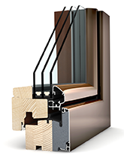
Your elements have the following common characteristics:

Glass spacer: ISO
Glass coating: Light
Glazing: | Triple 36mm coated clear glass 4btoughened/12Ar/4/12Ar/b4toughened (0.7W/m²K, 31dB, 3A2-IL_)

Hardware: X hardware (3D-hinges) (X)
Handle inside: Long handleplate in F1 (33851)
Handle outside: Long handleplate in F1 (33845)

Colour inside: spruce FI501 (FI501)
Colour outside: Anthracite grey RAL7016 matt (HM716)

Thermal insulation value window*: 0,90 W/m²K
Sound insulation value window*: 34dB
________________________________________________________________________________________________________________________________________________________

Internorm ambiente / UPVC/aluminium window KF310
• Slim-line: KF 310 with its construction depth of 74 mm belongs to the slim-line windows on the market.  • All around protection: Glass pane is bonded with window sash (I-tec glazing) ensuring excellent stability, thermal insulation and security.  • Excellent thermal insulation: 6 chambers in the frame with corresponding glazing ensure good thermal insulation.  • Triple gasket sealing system: Three continuous gaskets ensure reliable thermal insulation, sound reduction, weather proofing as well as being airtight.  • Aluminium clad: The high-quality aluminium clad on the outside facilitates almost unlimited colour possibilities.  • Construction depth: 74 mm | 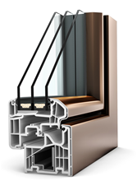

Your elements have the following common characteristics:

Glass spacer: ISO
Glass coating: Light
Glazing: | Triple 48mm coated clear glass 4btoughened/18Ar/4/18Ar/b4toughened (0.5W/m²K, 34dB, 3T6-IL_)

Hardware: X hardware (3D-hinges) (X)
Handle inside: Long handleplate in F1 (33851)
Handle outside: Long handleplate in F1 (33845)

Colour inside: Dark grey similar to 7016 (DG)
Colour outside: Anthracite grey RAL7016 matt (HM716)

Thermal insulation value window*: 0,76 W/m²K
Sound insulation value window*: 34dB
________________________________________________________________________________________________________________________________________________________

Pos. Quantity Description
________________________________________________________________________________________________________________________________________________________
100 | 1,00 | Pcs. | HF210 1-piece door with low threshold
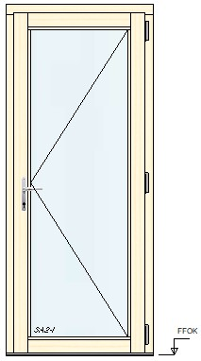 |  |  | Internorm timber/aluminium window – ambiente  width: 950mm, height: 2260mm,  frame system: CR - frame 95mm, low threshold according to ÖNORM 30mm,  Installation fields: TIF,  1st door sash (low threshold)  side entrance door Opening direction: right, handle height from sash bottom bead: 1065mm, cylinder: AZ profile 80/45 keyed to differ (ZA4BV), silver,  Element version:  connection bead/building connection: 30 mm connection bead PUR hard foam plate (30PU)  Extras: Element packaged,  adjusted for wall anchor hardware (01)  Altitude up to 900 m  Uw value (calculated): 0,93W/(m².K)  Warning:  Use low threshold doors only in protected fitting situations (limited protection against driving rain).

110 | 1,00 | Pcs. | KF310 1-piece door with low threshold
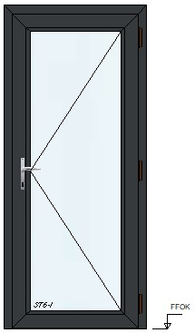 |  |  | Internorm UPVC/alu window – ambiente  width: 960mm, height: 2175mm,  frame system: CR - frame 95mm, low threshold according to ÖNORM 30mm,  Installation fields: TIF,  1st door sash (low threshold)  side entrance door Opening direction: right, handle height from sash bottom bead: 1070mm, cylinder: AZ profile 55/50 keyed to differ (ZA12BV), Cover caps black,  Accessories hardware: with third 3D hinge,  Element version:  connection bead/building connection: 30 mm UPVC connection bead (30)  Extras: Drainage to the front, Glazing bead gasket colour inside: black, gasket colour outside: black,  adjusted for wall anchor hardware (01)  Altitude up to 900 m  Uw value (calculated): 0,85W/(m².K)  Warning:  Use low threshold doors only in protected fitting situations (limited protection against driving rain).

________________________

GENERAL INFORMATION
Unless specifically mentioned elsewhere in this quotation, this estimate has been prepared on the understanding that;

The prices quoted include for all works detailed in this quotation and are valid only for the quantities quoted.

A Lifting Device may be required to off load the units upon site delivery this is supplied NOT by Ultimate Windows and Doors.

Lead flashings, cranes, scaffolding or pressings have not been included for in this quotation unless stated.

Aluminium Flashings and sills if required need to be surveyed after the fitting of the units which can take up to three to four weeks to include manufacture powder coating and fitting.

The prices quoted are valid for a period of 30 days from the date of quotation.

Prices are subject to our confirmed site survey dimensions. (Continued)

Should you wish to place an order we require a 60% deposit with confirmation of your requirements, 40% becomes payable upon delivery, before installation. We cannot commence survey and manufacture until we are in receipt of contract and deposit.

Delivery is approximately between 6 - 10 weeks for Internorm products depending on the selected profile design (This excludes shutdown periods, in August the first two weeks of the month for yearly maintenance and December one week holiday period)

After fitting details have been completed these need to be checked and signed off by an agreed party immediately.

We trust that this meets with your approval and look forward to a favourable response.
Yours sincerely
For Ultimate Windows
Paul Tristram

